1. Sources Code

Bootstrap.php🡪controller

v_bootstrap.php🡪view

2. URL

<http://localhost/pustaka_ajeng/Bootstrap>

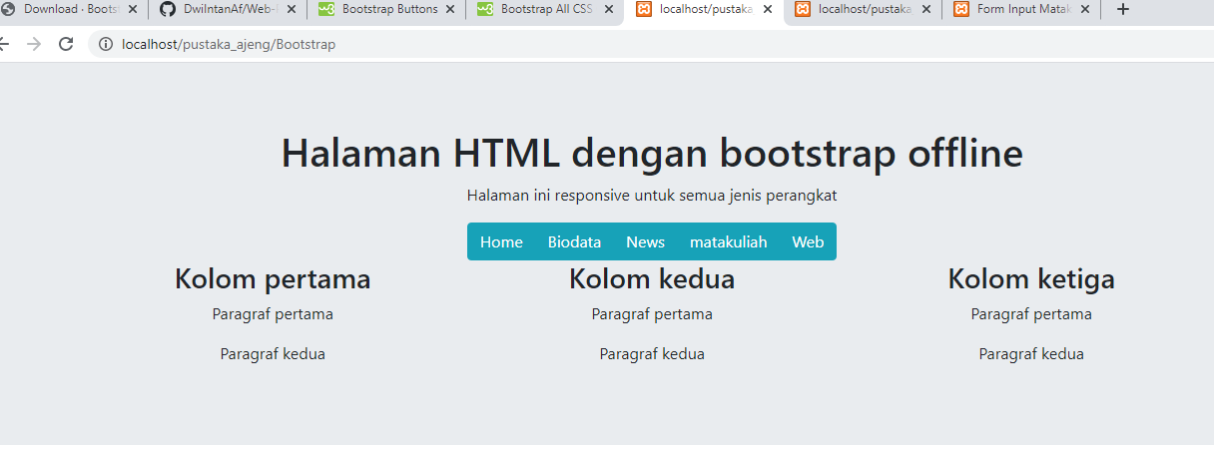3. Capture Output Program